User Guide 37 Certificate Manager guide to approving and renewing digital certificates
Purpose of this Guide
The purpose of this guide is to provide information for a Certificate Manager to approve or renew digital certificates.

NOTE: Before you can begin approving standard digital certificates you must ensure your digital certificate is installed in the Windows Certificate Store. Instructions can be found in User Guide 36 - Importing your digital certificate into Windows Certificate Store.
37.1 How to approve a standard digital certificate
When a member of your organisation enrols for a standard digital certificate, they will receive an email confirmation from DigiCert and must forward this email to you, as the Certificate Manager.
1. Once you have received the email, click the link to commence the approval process.
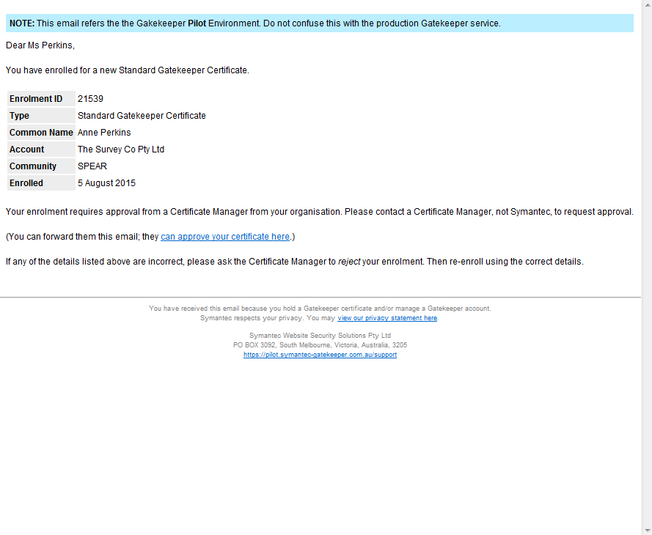
Click this link.

2. Once you have clicked this link, a dialog box will be displayed. Check that the certificate details match your own. Click ‘OK’ to move to the next step.
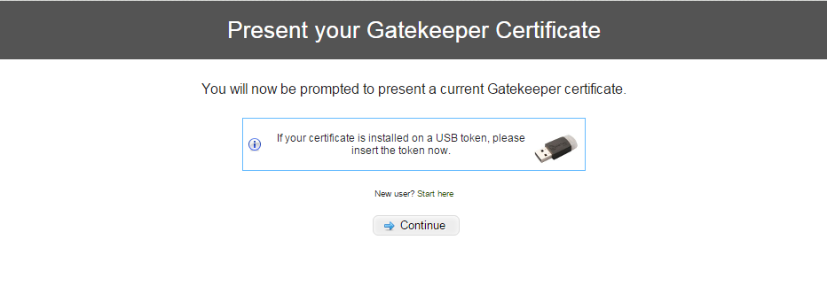

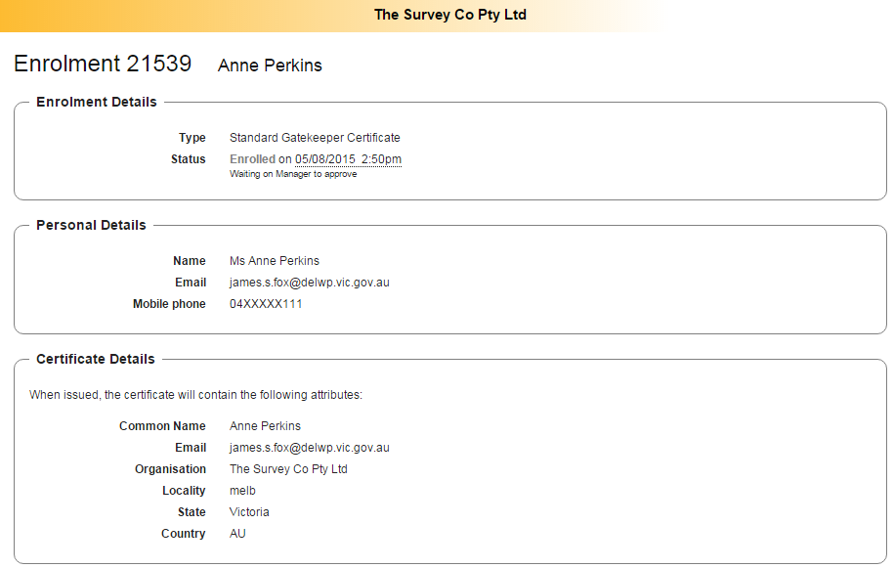
- Review the certificate details.

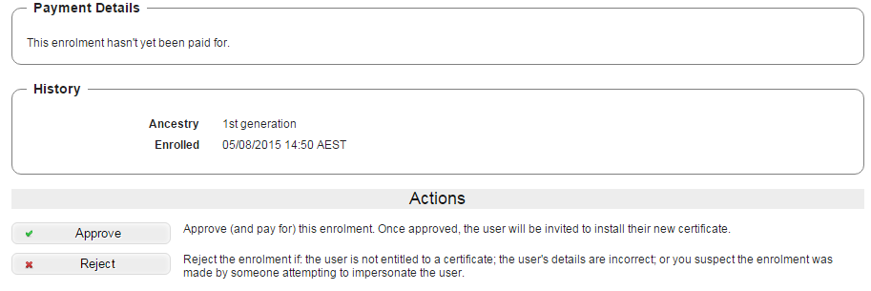
4. Choose to ‘Approve’, ‘Reject’ or ‘Renew’ the enrolment.

5. Choose a payment method and enter the payment details. Click ‘Continue’.
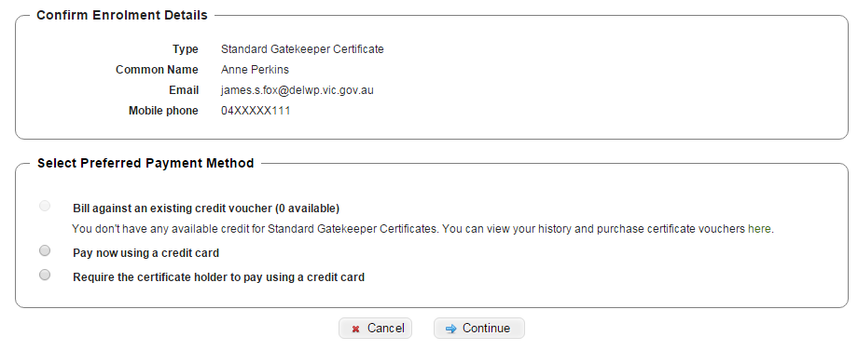

6. Review the enrolment details, complete declaration and approve certificate.
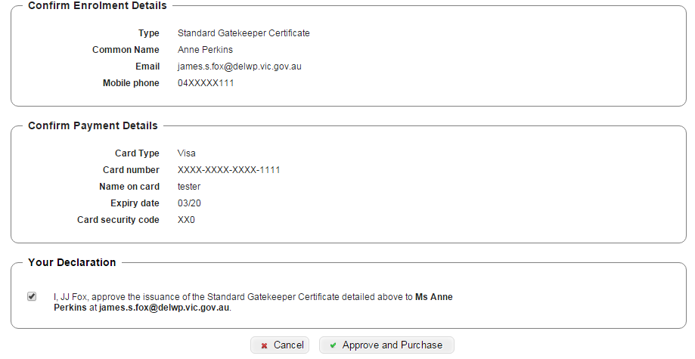

7. You should now have a message confirming you have approved the certificate.
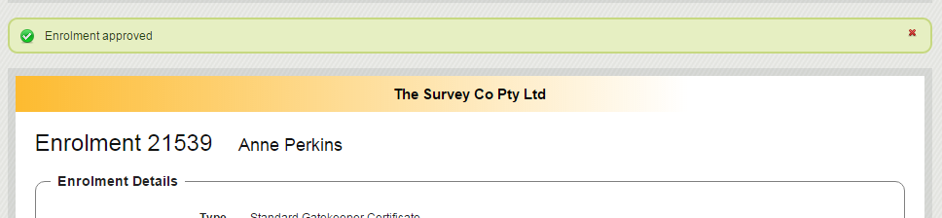

Next Steps:
The person who applied for the standard digital certificate will receive an email from DigiCert with instructions on how to download and back up their certificate.
Further information can be found in one of the following User Guides:
- User Guide 33A - Installing and backing up your digital certificate – Internet Explorer
- User Guide 33B - Installing and backing up your digital certificate – Firefox
- User Guide 33C - Installing and backing up your digital certificate – on an e-Token
37.2 How to approve a digital certificate renewal
Digital certificates are valid for two (2) years. DigiCert will send a renewal email to the Certificate Manager approximately 45 days before current certificates expire.
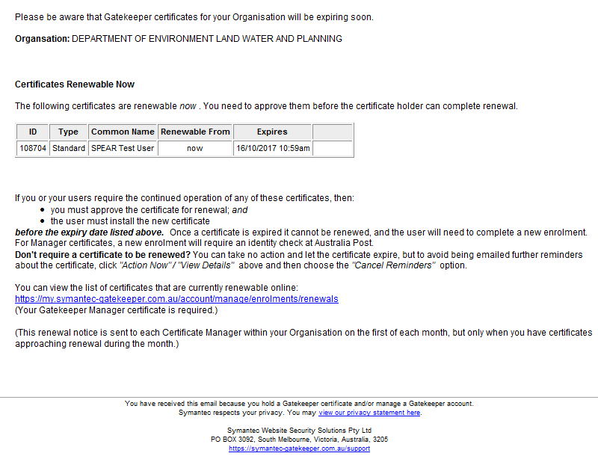
- A renewal email is received.
Click on this link.

- Follow steps 2 to 7 of section 37.1 (above) to approve the renewal.
Next Steps:
The recipient of the digital certificate will receive an email confirming the renewal of their certificate.
Once certificates have been received from DigiCert you will need to download and back them up. Further information can be found in one of the following User Guides:
- User Guide 33A - Installing and backing up your digital certificate – Internet Explorer
- User Guide 33B - Installing and backing up your digital certificate – Firefox
- User Guide 33C - Installing and backing up your digital certificate – on an e-Token
Need more information?
Further information on this topic can be found by:
- Visiting the SPEAR website www.spear.land.vic.gov.au/SPEAR
- Contacting the DigiCert helpdesk on (03) 9914 5600
- Contacting the SPEAR Service Desk on 9194 0612 or email spear.info@delwp.vic.gov.au

